|  |  |
| --- | --- |
|  | FPT ACADEMY INTERNATIONAL  FPT – APTECH COMPUTER EDUCATION |

Centre Name: ACE-HCMC-2-FPT.

Address: 590 Cach Mang Thang 8, District 3, Ho Chi Minh City, Viet Nam.

**THE DESTINATION**

|  |  |  |
| --- | --- | --- |
| Supervisor: | Phạm Thị Lánh | |
| Term: | T1.2208.M0 | |
| Batch No: | 1 | |
| Group No: | 1 | |
| Order: | Full name | Roll No. |
| 1. | Đồng Đại Dương | Student1405200 |
| 2. | Trần Ngô Tấn Thịnh | Student1405191 |
| 3. | Nguyễn Vũ Cao Sơn | Student14052189 |
| 4. | Phạm Trần Lê Minh | Student1405184 |

Month 04 Year 2022

This is to certify that

**Mr. Đồng Đại Dương**

**Mr. Trần Ngô Tấn Thịnh**

**Mr. Nguyễn Vũ Cao Sơn**

**Mr. Phạm Trần Lê Minh**

Have successfully Designed & Developed

**NOTHING IMPOSIBLE**

Submitted by: **Ms. PHAM THI LANH**

Date Of Issue: November, 2022

Authorized Signature:

# Content

Content 3

Acknowledge 4

Synopsis 5

REVIEW 1 6

Problem Definition 7

Customer Requirements Specifications 7

Site map 9

Screen shots 10

Homepage 10

Galary 11

information page 12

club page 13

Task Sheet 14

REVIEW 2 15

I. WEBSITE USER INTERFACE 16

1. Home Page 16

2. Galery 17

3. Organization 22

4. Information 23

5. About us 27

# Acknowledge

As we understand that the eProject is a step-by-step learning environment that closely simulates the classroom and Lab based learning environment into actual implementation. It is a project implementation at your fingertips!! An electronic, live juncture on the machine that allows you to.

✓ Practice step by step i.e., laddered approach.

✓ Build a larger, more robust application.

✓ Usage of certain utilities in applications designed by the user.

✓ Single program to unified code leading to a complete application.

✓ Learn implementation of concepts in a phased manner.

✓ Enhance skills and add value.

✓ Work on real life projects.

✓ Give a real-life scenario and help to create applications more complicated and useful.

✓ Mentoring through email support.

We would like to send a great thank to our professor and others student for the adorable support during the time in the project.

Beside several mistakes we had made in the project, we hope to have more opportunities to widen our knowledge in the web developing world.

We also thank you so much for your information and the “demo” project from India APTECH to help us get more reality experience in this project. Since we have gained more experience from this project, we will not stop learning anything as much as we can to be more successful in the future.

Your Sincerely,

Team Group 06.

# Synopsis

- The Objective of this program we aim is to give a sample project to work on real life projects. These applications help us build a larger, more robust application.

- The objective is not to teach us HTML/JavaScript but to provide us with a real life scenario and help us create basic applications using the tools.

- Hence, we can revise the chapters before we start with the project.

- This project The Objective of this program is to give a sample project to work on real life projects. These applications help you build a larger, more robust application.

- The objective is not to teach you the software but to provide you with a real-life scenario and help you create basic applications using the tools.

- You can revise the topics before you start with the project.

- This project is meant for students who have completed the module of HTML5.

- These programs should be done in the Lab sessions with assistance of the faculty if required.

- The website (in this project) is a tool that help the company to access the

international market and gain more and more new customers.

- It is very essential that a student has a clear understanding of the subject.

# 

# REVIEW 1

## Problem Definition

Our webpage will provide general information about climbing and mountainerring. Aside it will show mountains famous position and suggest tour relative it

A website needs to be designed to display various lights available with the store. Details of locations using GeoLocation API (eg. GoogleMaps), feedback must be included.

The website is to be developed for the Windows Platform using HTML5, JavaScript and Geolocation. The site should work well in all leading browsers including Chrome, IE, Firefox etc.

Here are some problems need to be resolved:

1. With the changing environment, more and more customers are interested in shopping online and this issue leads to the situation that customers want to find information about various products easily on the Bright World website and purchase the right product that meets their needs.

2. The product range is not known to quite a few customers; they just order on the basis of the feedback or recommendations given by their friends or colleagues and after delivery of the product it does not match either the requirements or expectations leading to wastage of time, resources and delivery costs.

3. Online customers have an interest in reading reviews before purchasing specific products.

4. Existing customers needing some help and support on the product after installation would have to contact the Bright World office through a phone number or email address. Moreover, many customers want to come to the store to view the product and then decide whether to buy it or not.

## Customer Requirements Specifications

|  |
| --- |
| USER: |
| Input:  ● Input consumer’s address of residence or office  ● Send questions/requests to the company |
| Process:  ● Process consumer’s address data  ● Collect questions/requests sent by consumers |
| Output:  ● Show the store address to consumers  ● Reply to the consumer’s requests/questions |

|  |
| --- |
| WEBMASTER: |
| Input:  ● Control website database, input product information,… |
| Process:  ● Analyse website |
| Output:  ● Website interface, images, forms, …  ● Giving interaction |

|  |
| --- |
| HARDWARE / SOFTWARE REQUIREMENT: |
| Software:  ● Notepad/HTML editor  ● Dreamweaver/Javascript |
| Hardware:  ● A minimum computer system that will help you access all the tools in the courses is a Pentium 166 or better  ● 64 Megabytes of RAM or better |

## Site map

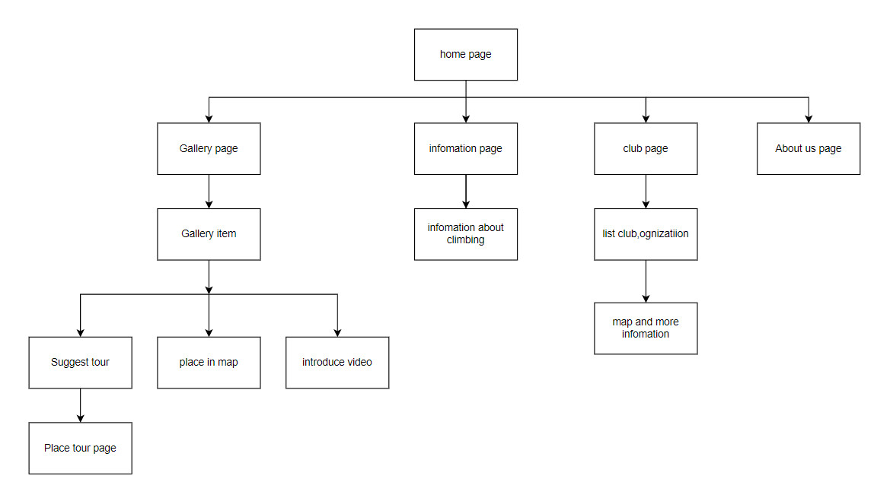

## Screen shots

### Homepage

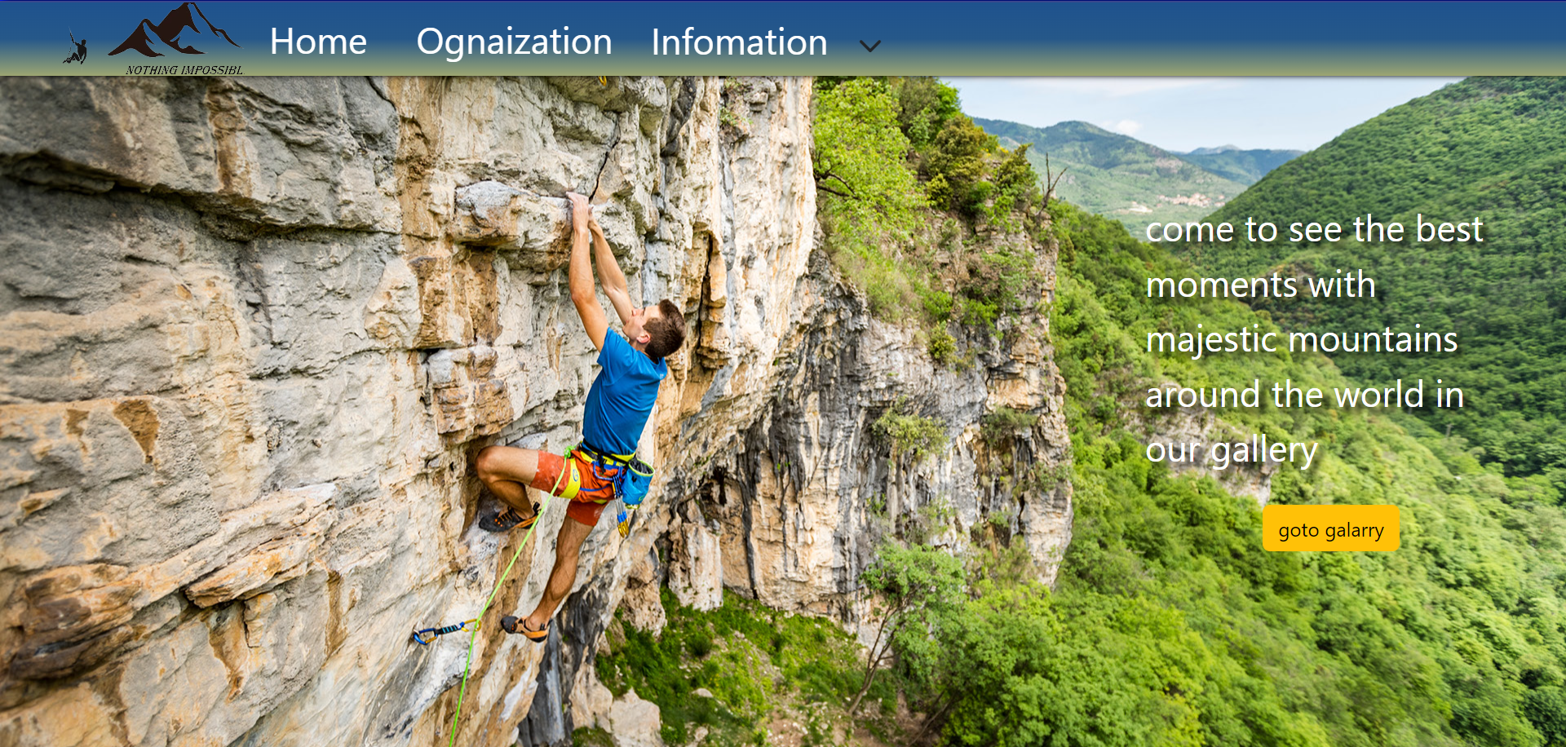

**Description:** This is a homepage of Bright World, the top of this page is a header, after that is a navigation bar. includes 4 sections: home, goto galarry,information and ognaization

### Galary

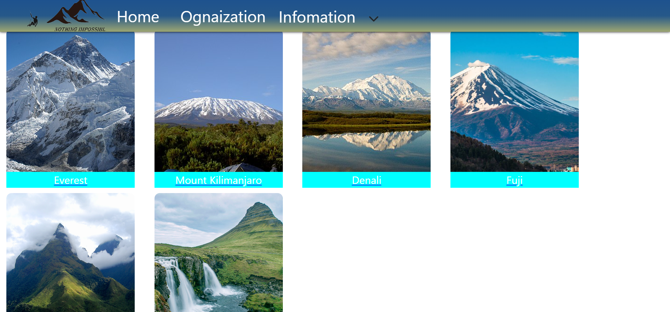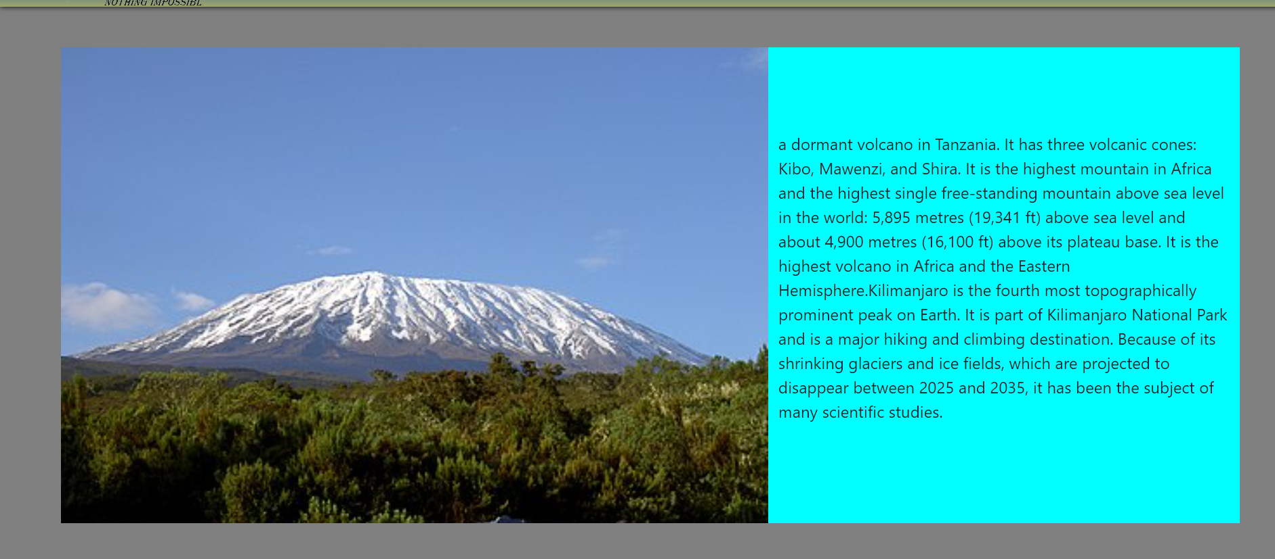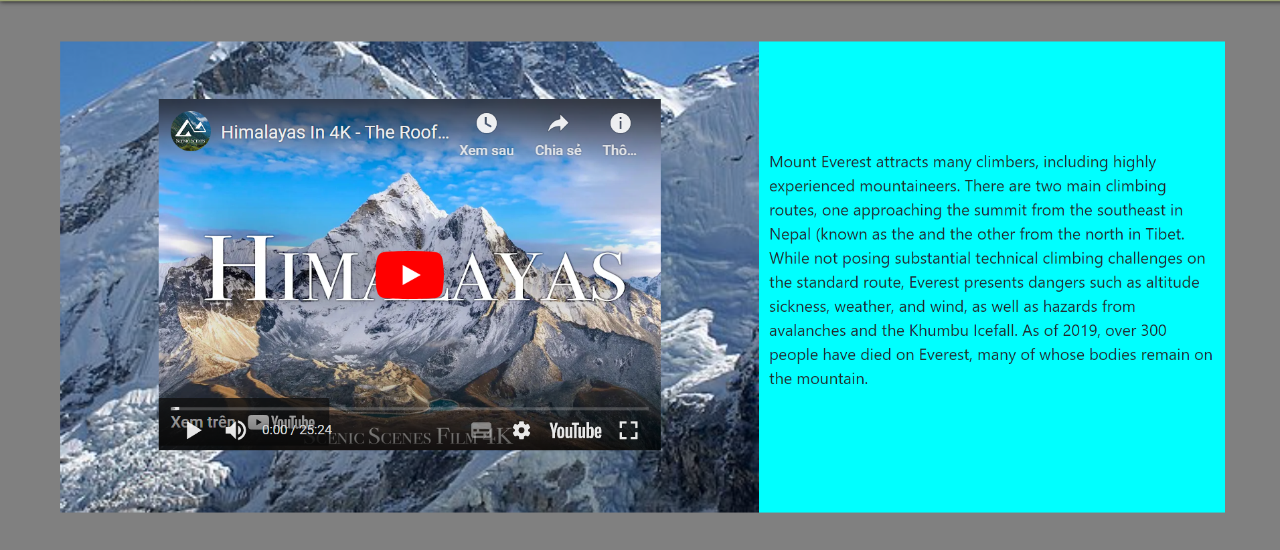

**Description:** this page will show famous mountain in the world .each item will include info mation , picture and more info mation after click.

### information page

**Description**.it will include infomations is required (history, style shelter,hazzad..)

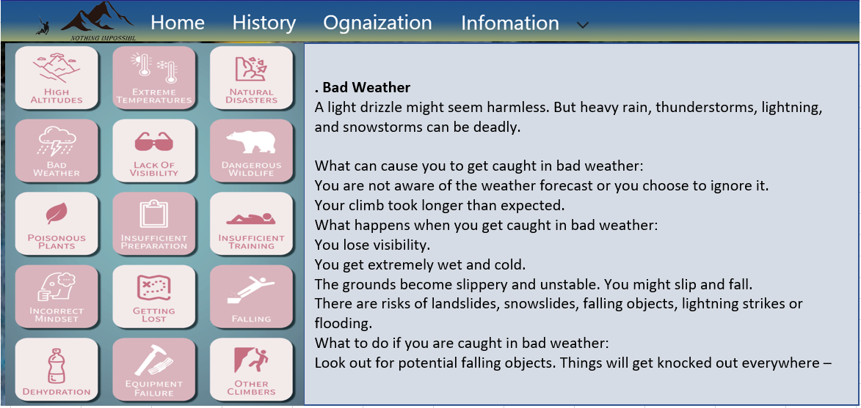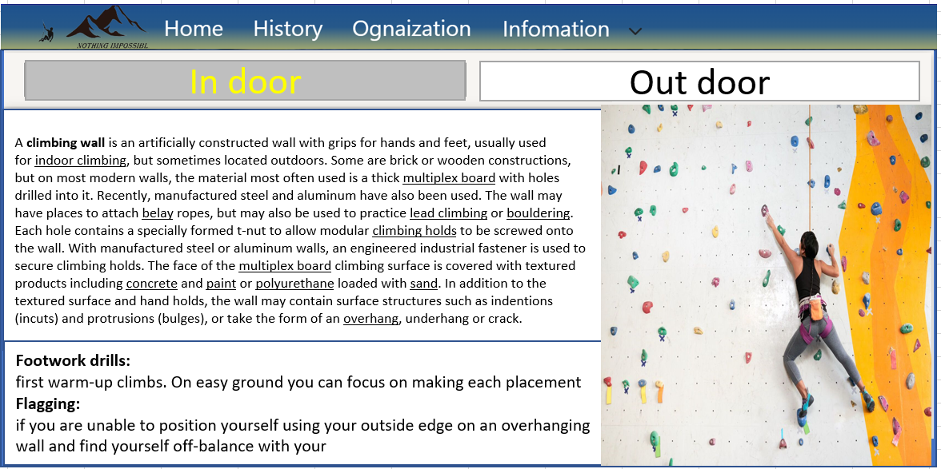

### club page

**Description:** Page show some club or ognization relative ro climbing or mountaineering. After click have modal show more information , location in map and link to their webpage.

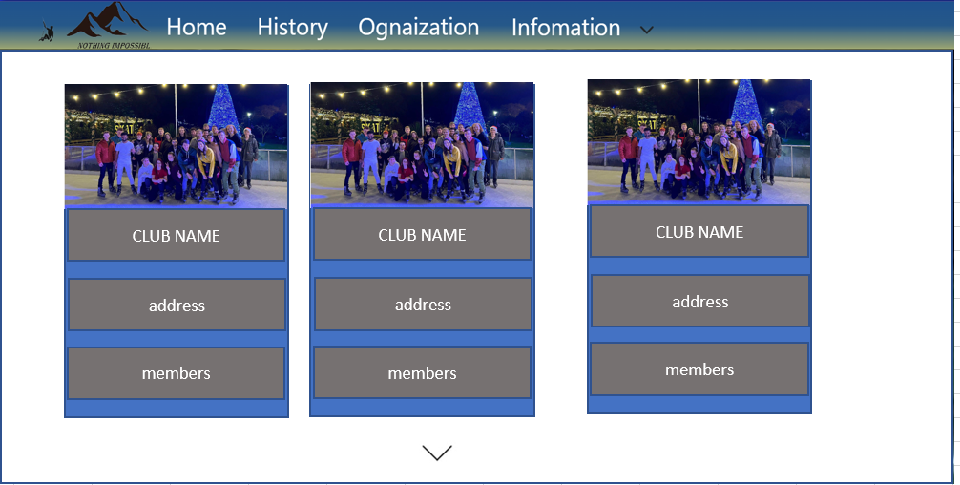

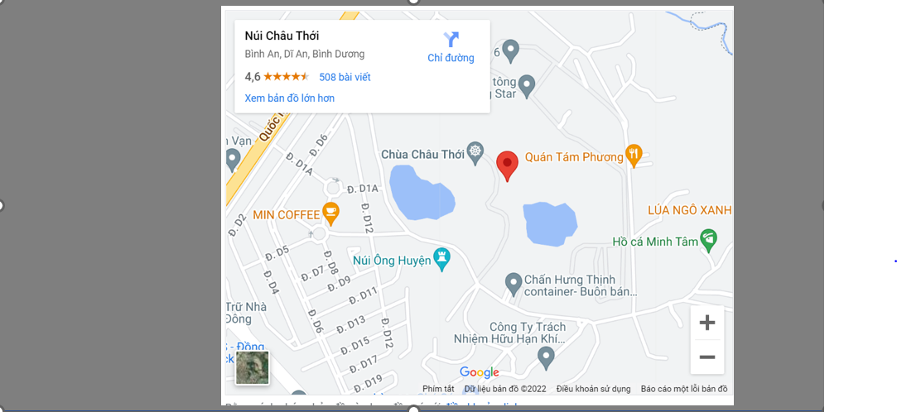

## Task Sheet

|  |  |  |  |  |  |  |
| --- | --- | --- | --- | --- | --- | --- |
| **Project Ref No.** | **Project Title – Ask Me Mobile** | **Activity Plan Prepared by** | **Date of preparation of Activity Plan** | | | |
| **Task** | **Actual Start Date** | **Actual Days** | **Teammate Names** | **Status** |
| Brainstorming ideas for layouts and Project Object | | Nam, Sơn, Anh | 30/03/2022 | 1 days | Nam, Sơn, Anh | Completed |
| Draw site maps and architecture design | | Nam, Sơn, Anh | 30/03/2022 | 1 days | Nam, Sơn, Anh | Completed |
| Wire framing general page layout | | Anh | 02/04/2022 | 3 days | Anh | Completed |
| Collect static assets (pictures, mp4, documentation,…) | | Nam, Sơn | 02/04/2022 | 5 days | Nam, Sơn | Completed |

# 

# REVIEW 2

# I. WEBSITE USER INTERFACE

### 1. Home Page

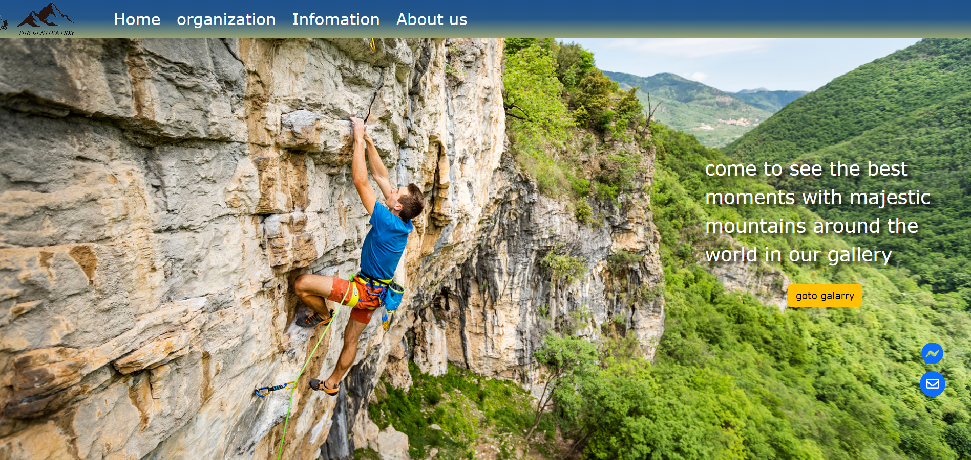

*Image 2.1: Home Page*

**Description:** The header of the Home page shows a navigation bar including 4 sections linked to 4 sub information pages: Home, Organization, Information, About Us. In the Home page background, it includes the “go to Galary background” button which used to move to Galary page.

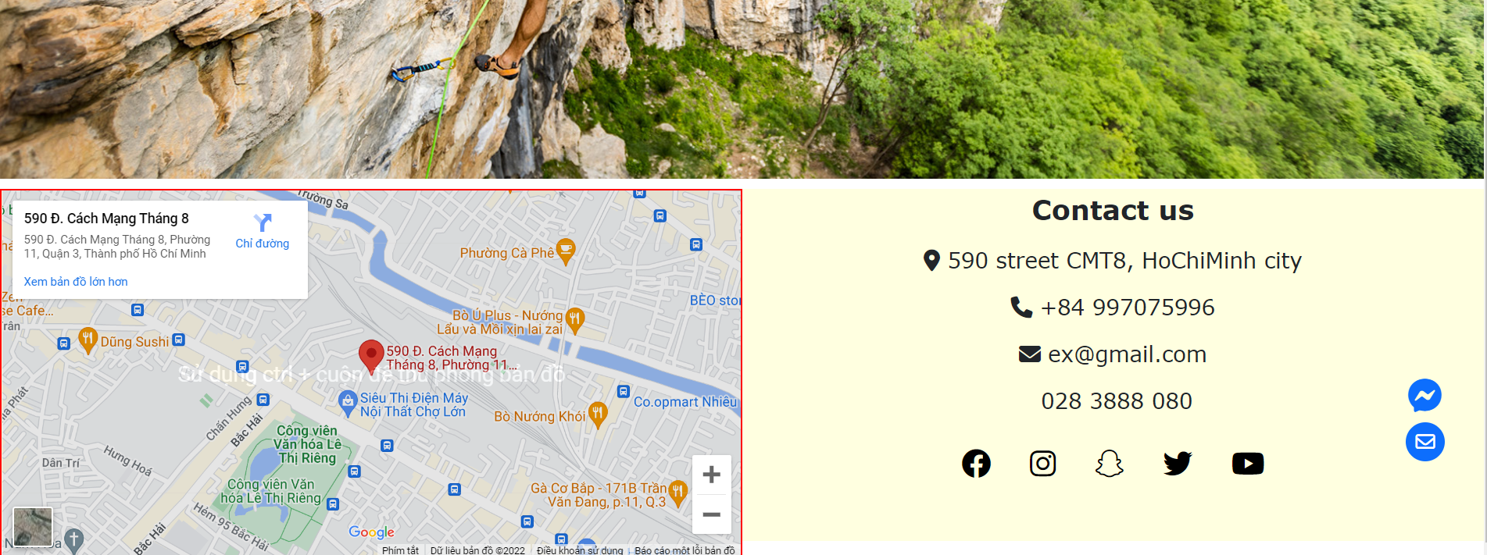

*Image 2.2: Footer*

**Description:** The left information of the footer shows location of Group 6 Workplace. The right side of footer include some information for contacting such as: address, phone, email, youtube channel, twitter, etc.

### 2. Galery

When user clicks to “Go to Galery” button, Home page will be moved to Galery page.

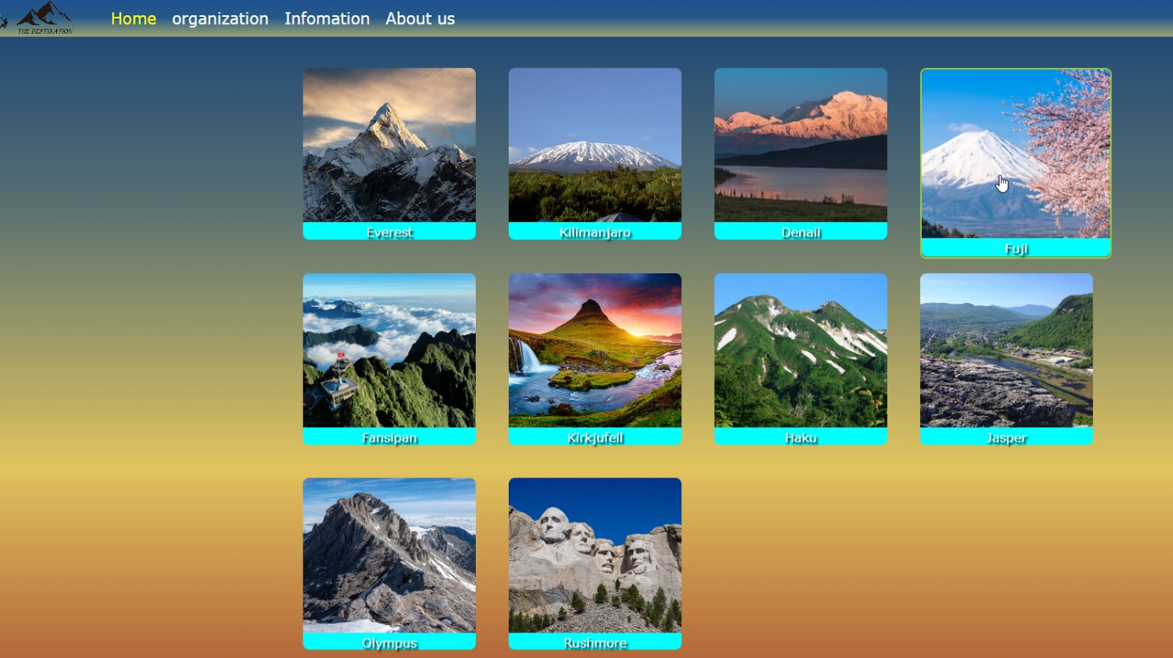

*Image 2.3: Galary page*

**Description:** Galery page contain 10 sections showing the names and images of mountains. There are 10 mountains including: Everest, Kilimanjaro, Denali, Fuji, Fansipan, Kirkjufell, Haku, Jasper, Olympus, Rushmore.

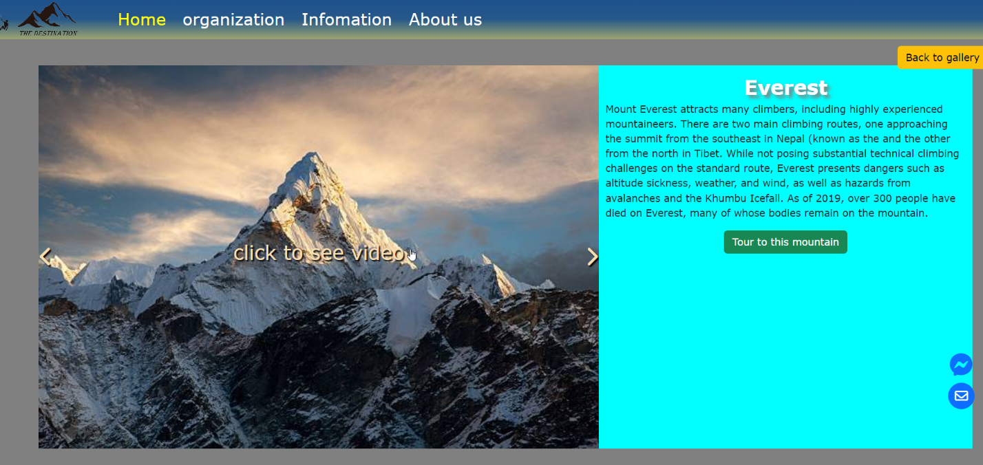

*Image 2.4: Detail information of mountain in Galery*

**Description:** When user click to every mountain image, it will move to the new page which describe the name, information, and 3 images of each mountain. User can use the “<” and “>” button to see other mountain images. User can use the “Back to Galery” button to move back to Galery Page.

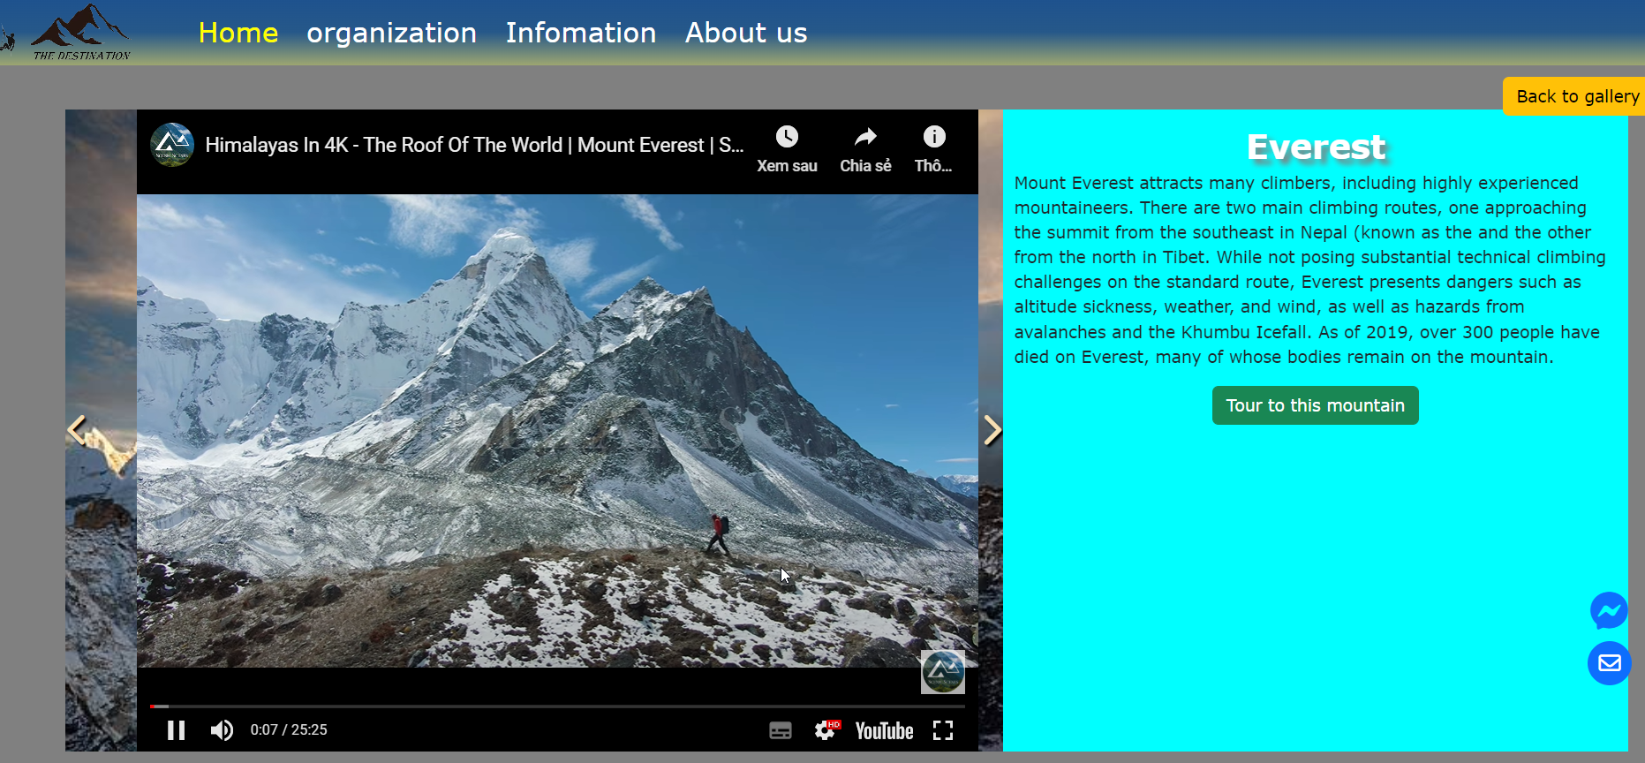

*Image 2.5: Galery video*

**Description:** If user click to “click to see video” section, it will show the video of the moutain. Further more, if you want to travel to one of these moutains, you can click to “Tour to this mountain” button to move to Tour Page.

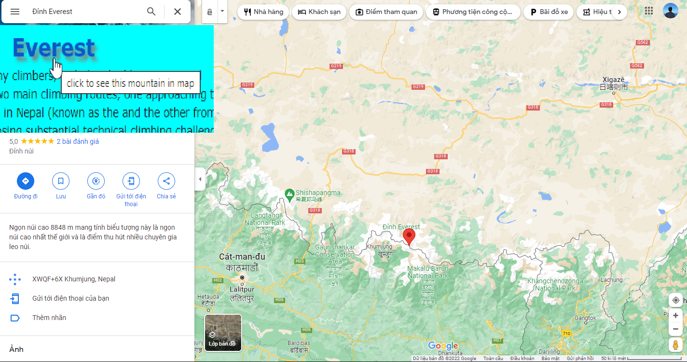

*Image 2.6: Mountain location*

**Description:** Click to the name of the mountain, web page will be moved to the Google Map page to show the location of this mountain.

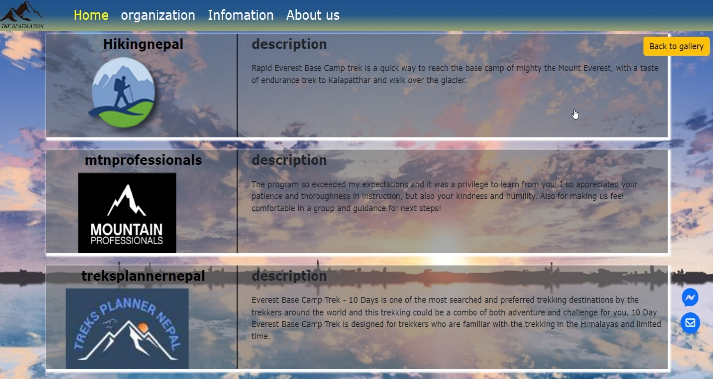

*Image 2.7: Tour page*

**Description:** When user click to the Tour Page of Everest mountain, there are Tour suggest pages.

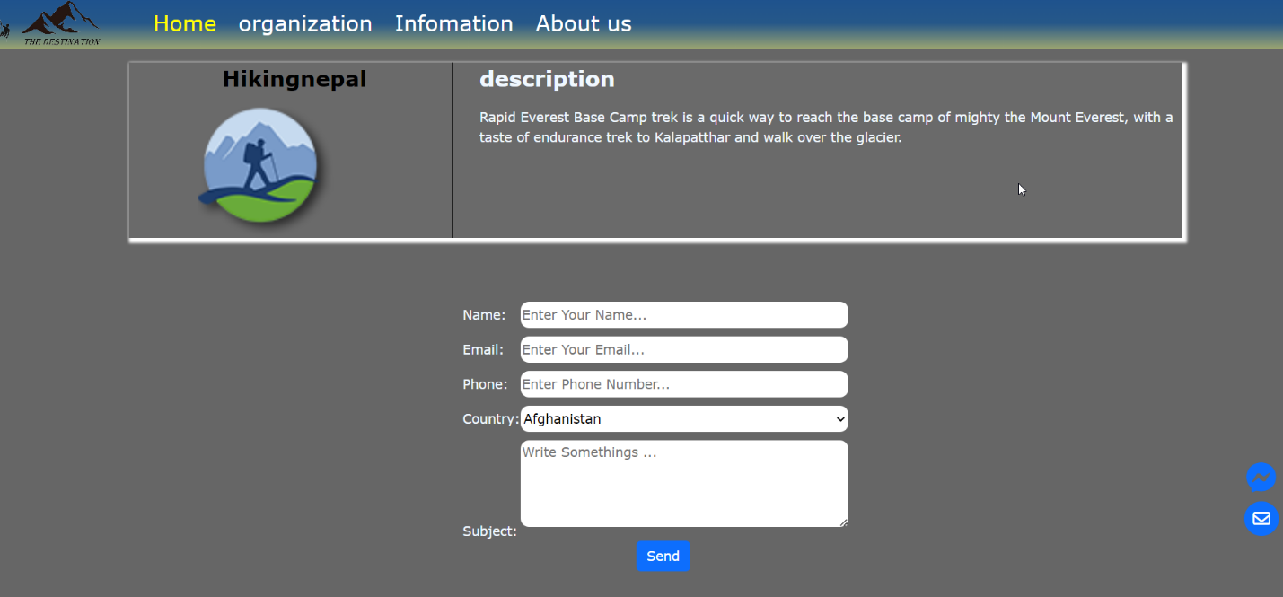

*Image 2.8: Tour Registration*

**Description:** If user chooses one of these Tours, website will be moved to a booking page. At here, we have to provide some informations for registering tour.

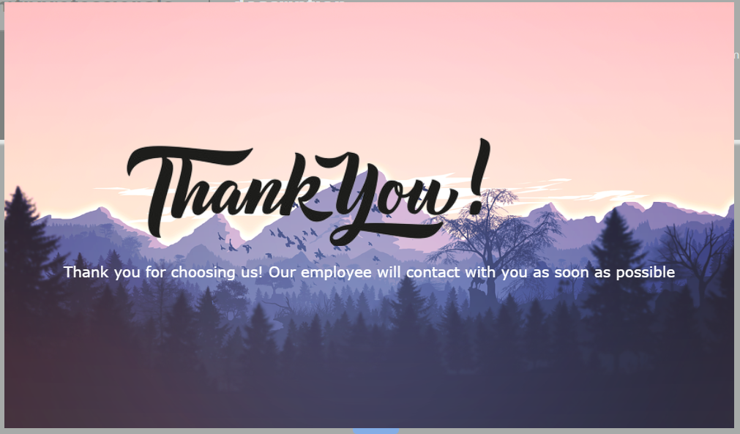

*Image 2.9: Thank you*

**Description:** After finishing the form validation, our website will show the board to thank user for choosing us.

### 3. Organization

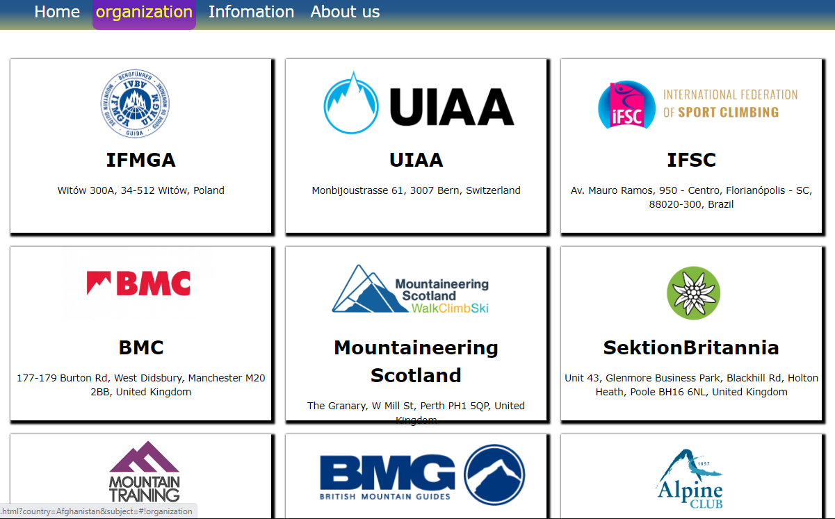

*Image 2.10: Organization page*

**Description:** Moving to the second section on the Nav bar, the information of Mountaineering Organization in the world will be showed on this page.

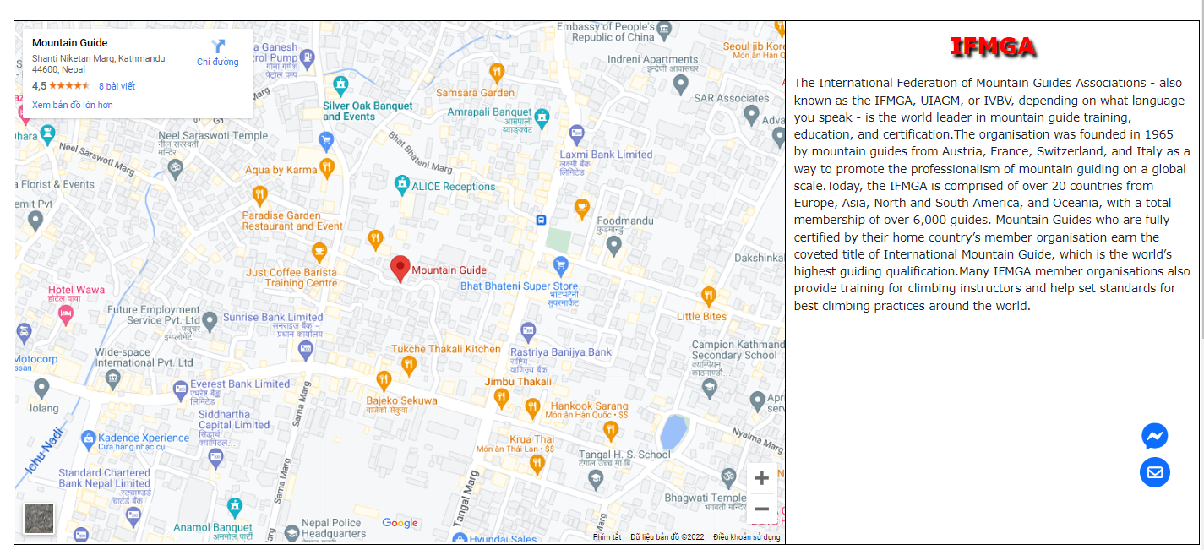

*Image 2.11: Details of organization*

**Description:** When user click to one of the organizations, our Web will show the information and location of organization. If you want to know the information in more detail, you can click to the name of the organization. The name is linked to the website of this mountaineering organization.

### 4. Information

There are 5 sections including History, Hazard, Style, Shelter and Skill in the Information page. We also have a hide and show button containing 5 sections and we can move to each sections when we click to the tittle of the section.

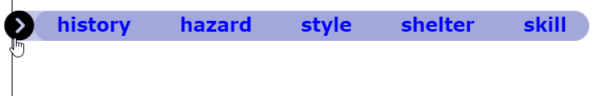

*Image 2.12: 5 sections of Information page*

*Image 2.13: History section*

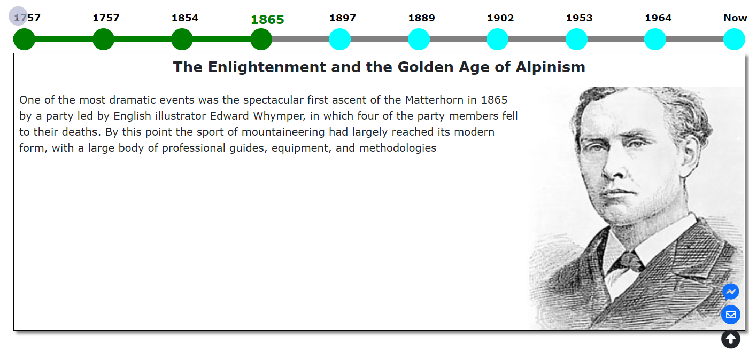

**Description:** History section will show the history of mountaineering and famous climber with the timeline from 1757 to the present. User can read different information by clicking on the button below the year, the color will be change from the first year to the year that user click on.

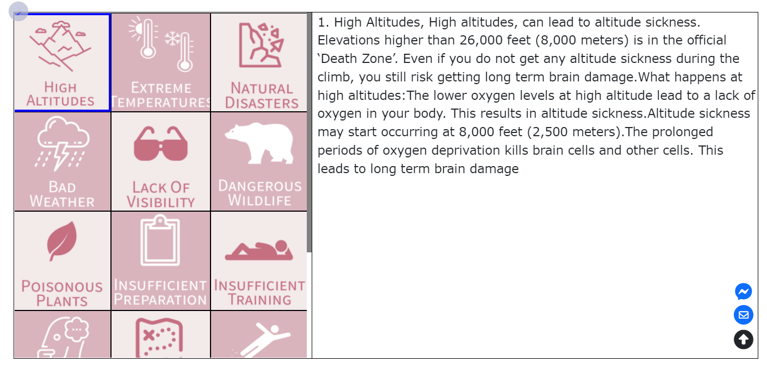

*Image 2.14: Hazard section*

**Description:** The number one danger of mountain climbing is the lack of awareness. Mountain climbing has its inherent environmental dangers. Therefore, we provide the list of 15 potential dangers that you would face on the mountains. Each icon provides the information of danger belonged to it.

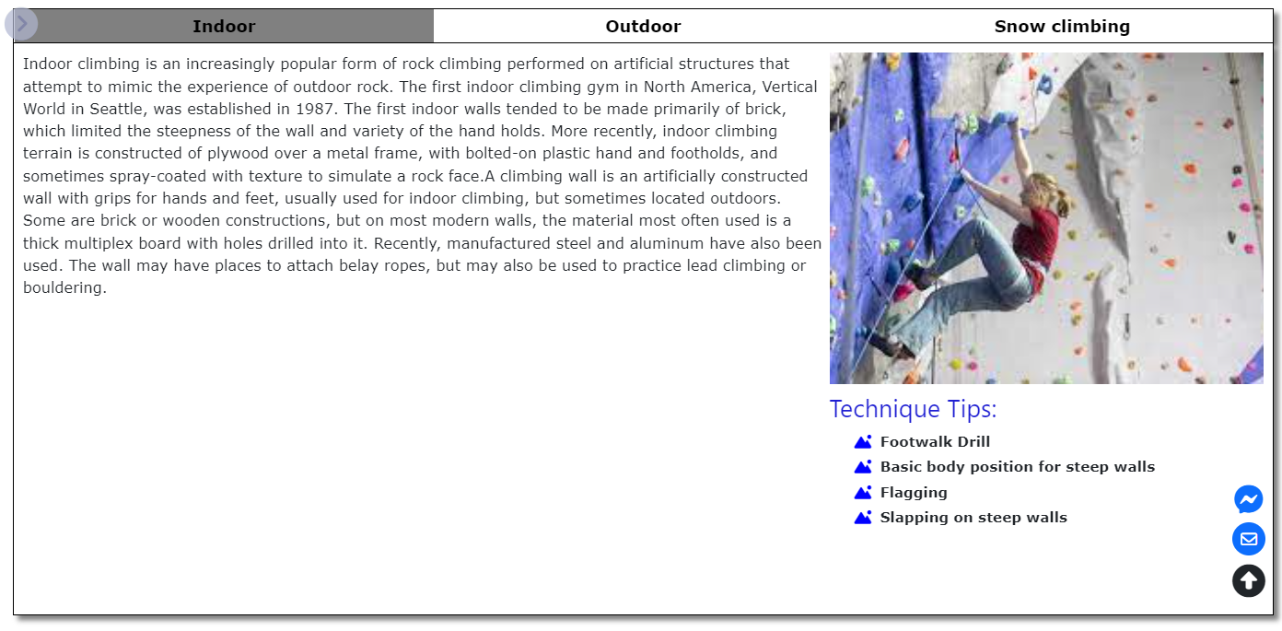

*Image 2.15: Style section*

**Description:** The Style section contain 3 different style of mountaineering: Indoor, Outdoor, and Snow Climbing. User can click to each tittle to gain more knowledge of mountaineering style and each style contain 3 automatic change image.

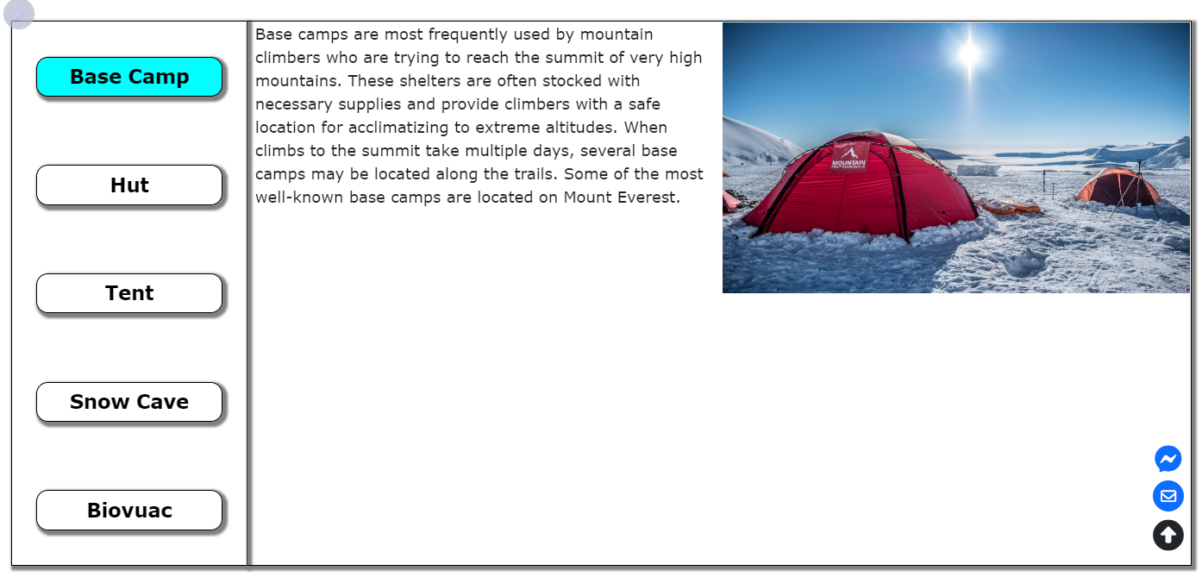

*Image 2.16: Shelter section*

**Description:** The shelter section shows general information of Base Camp, Hut, Tent, Snow Cave and Biovuac.

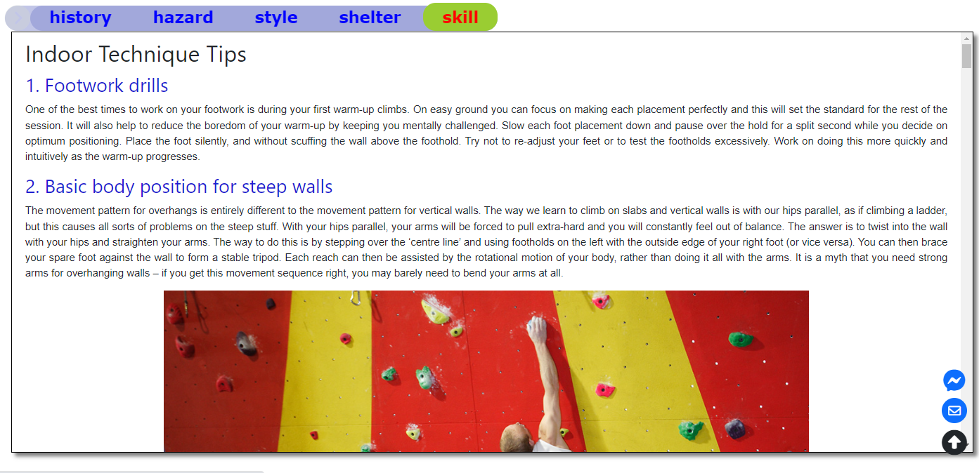

*Image 2.17: Skill section*

**Description:** The last section is Skill which show the Technique Tips for 3 styles of mountaineering in more detail, it also includes image and video to guide for climber.



*Image 2.18: Return Button*

**Description:** Moreover, our Web page also have a arrow button which will lead user to move to the first section of Information Page.

### 5. About us

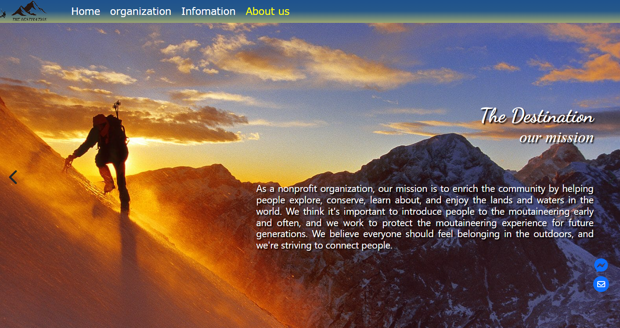

*Image 2.19: About us page*

**Description:** The final section on Nav bar is About The Destination team, user can click to “<” and “>” Button to switch slide get more information about us.

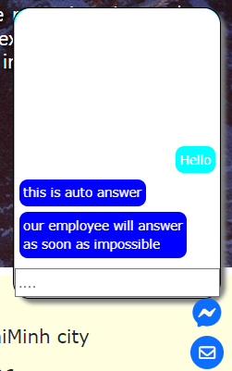

**Description:** Further more, we also provide a button for user that they can give direct message or send email to our Web page.